# Analysis Worksheet

1. **Include a photo of your calculation of your prediction for the max height that you performed in the lab, showing your TA’s signature. This should list all the values you measured and their uncertainties.**

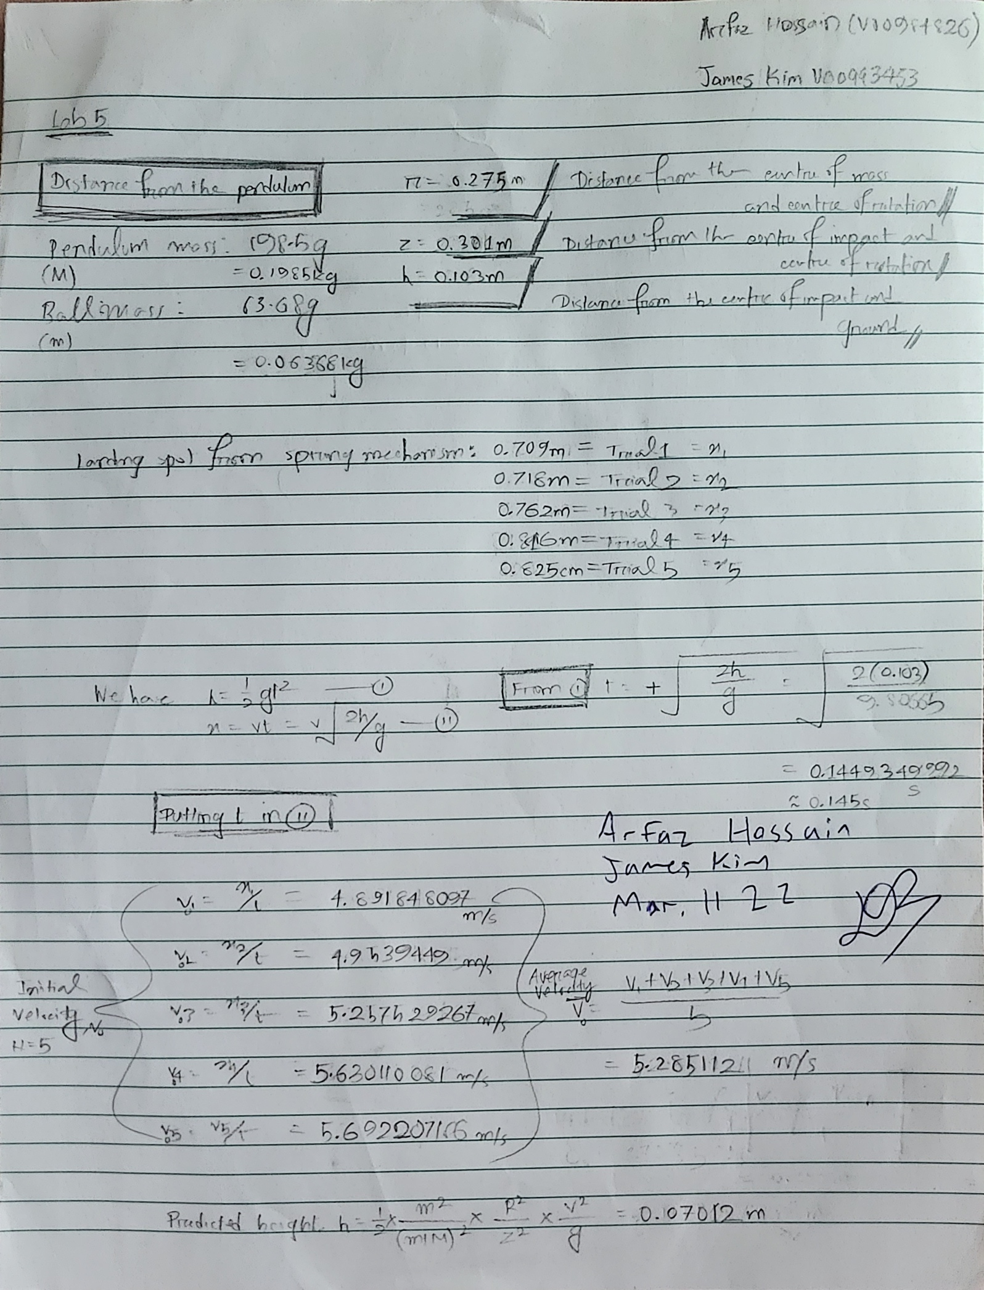

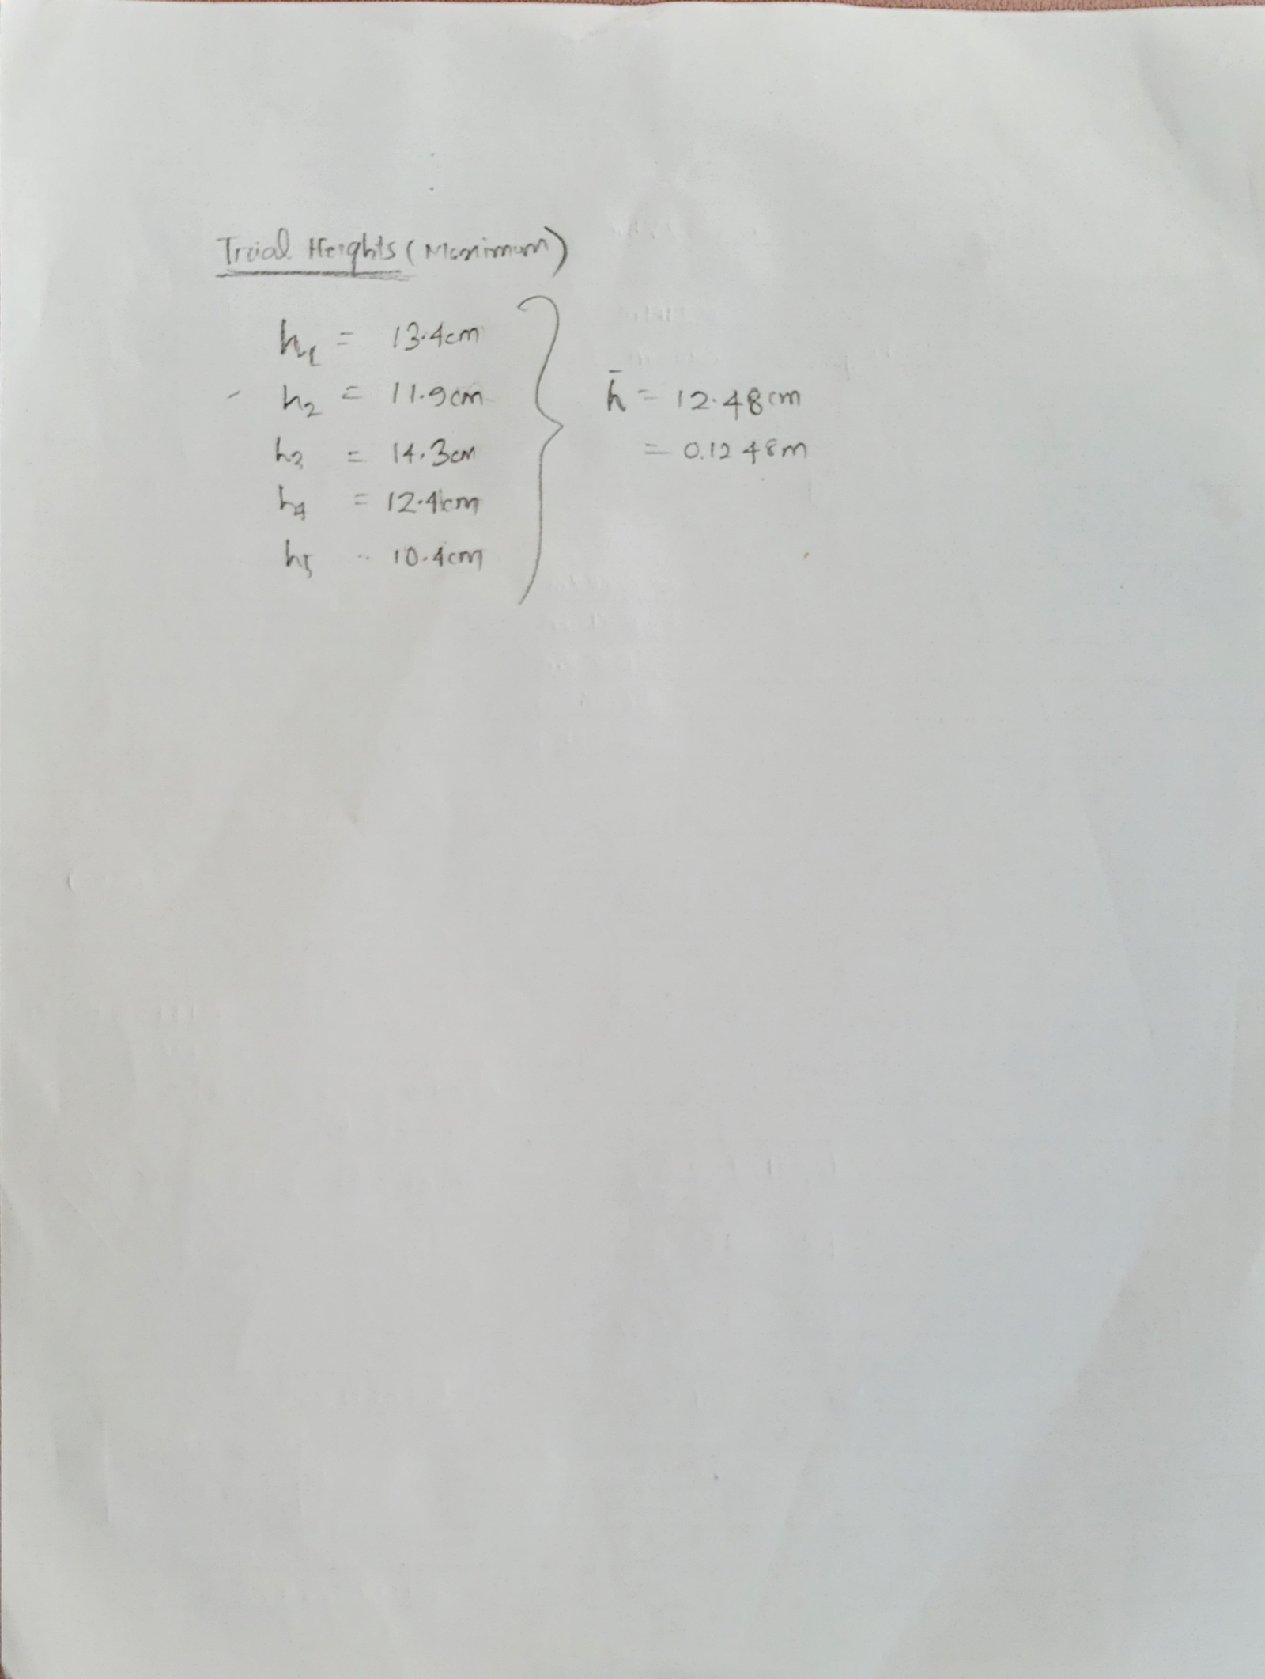

***Figure 1-2: Lab Submission (with signature)***

1. **Include photos of your pendulum arc papers, showing your TA’s signature.**

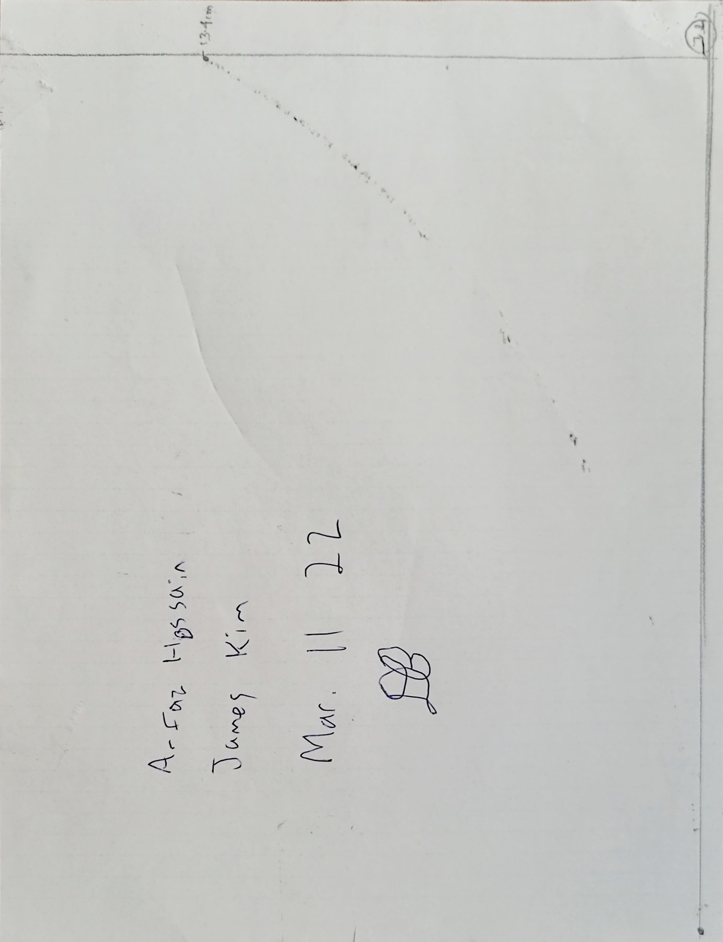

***Figure: Trial 1***

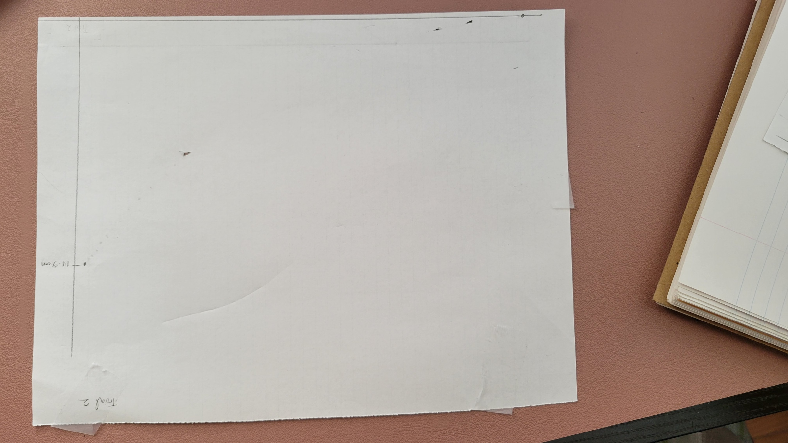

***Figure: Trial 2***

*please turn to next page*

**

***Figure: Trial 3***



***Figure: Trial 4***

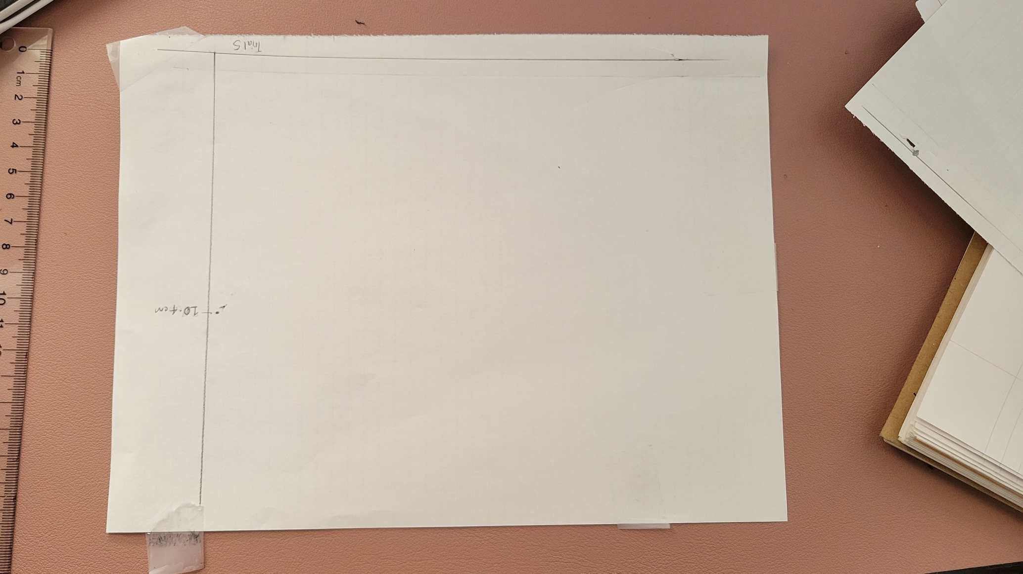

***Figure: Trial 5***

1. **Create a table of your distance and speed information, as describe in the Activity & Analysis section of the lab manual.**

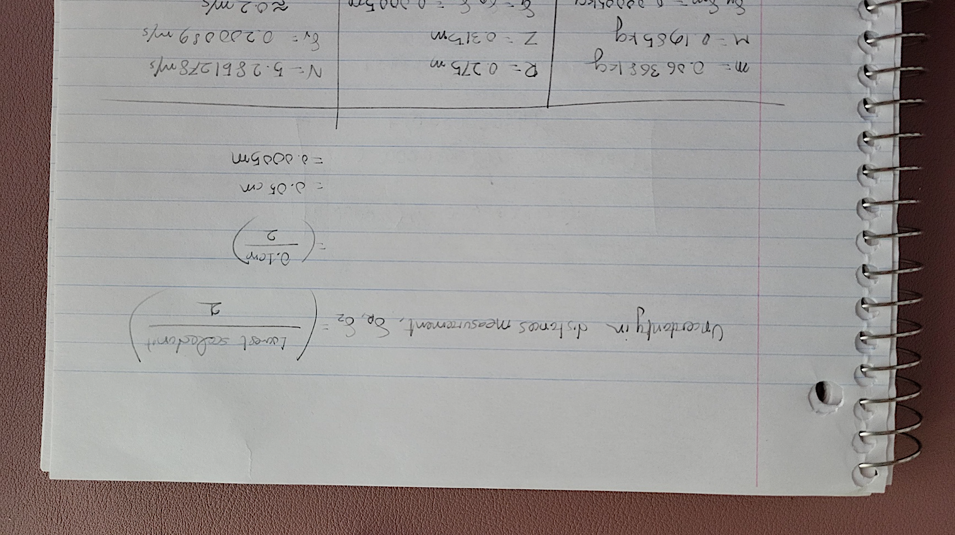

***Figure: Measurement uncertainty in distances.***

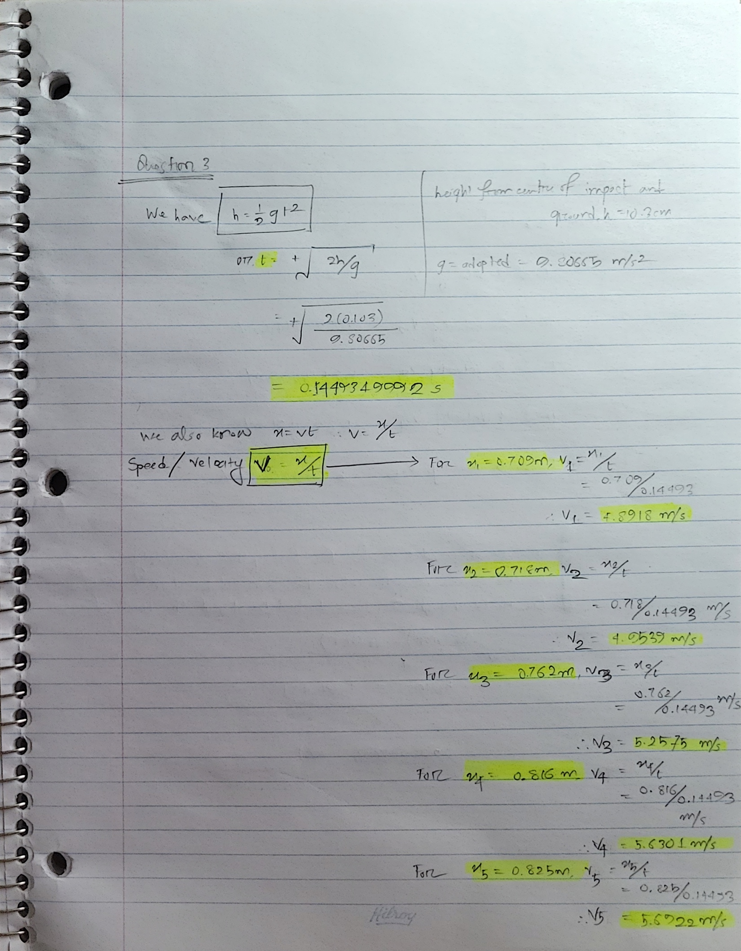

***Figure: Table 1 Calculations***



***Figure: Table 1***

1. **Calculate the average and uncertainty in the speed of the projectile. It is sufficient to show the formulas you use without showing intermediate steps of plugging in numbers. You do not need to perform uncertainty propagation, as the uncertainty in speed is statistical in nature.**

*please turn to next page*

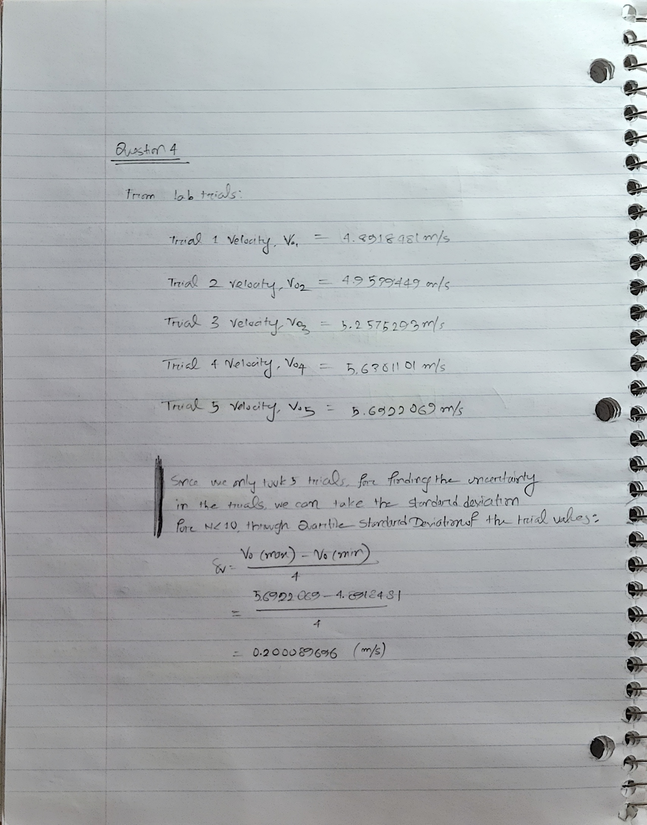

***Figure: Velocities in each trial and their measured uncertainty.***

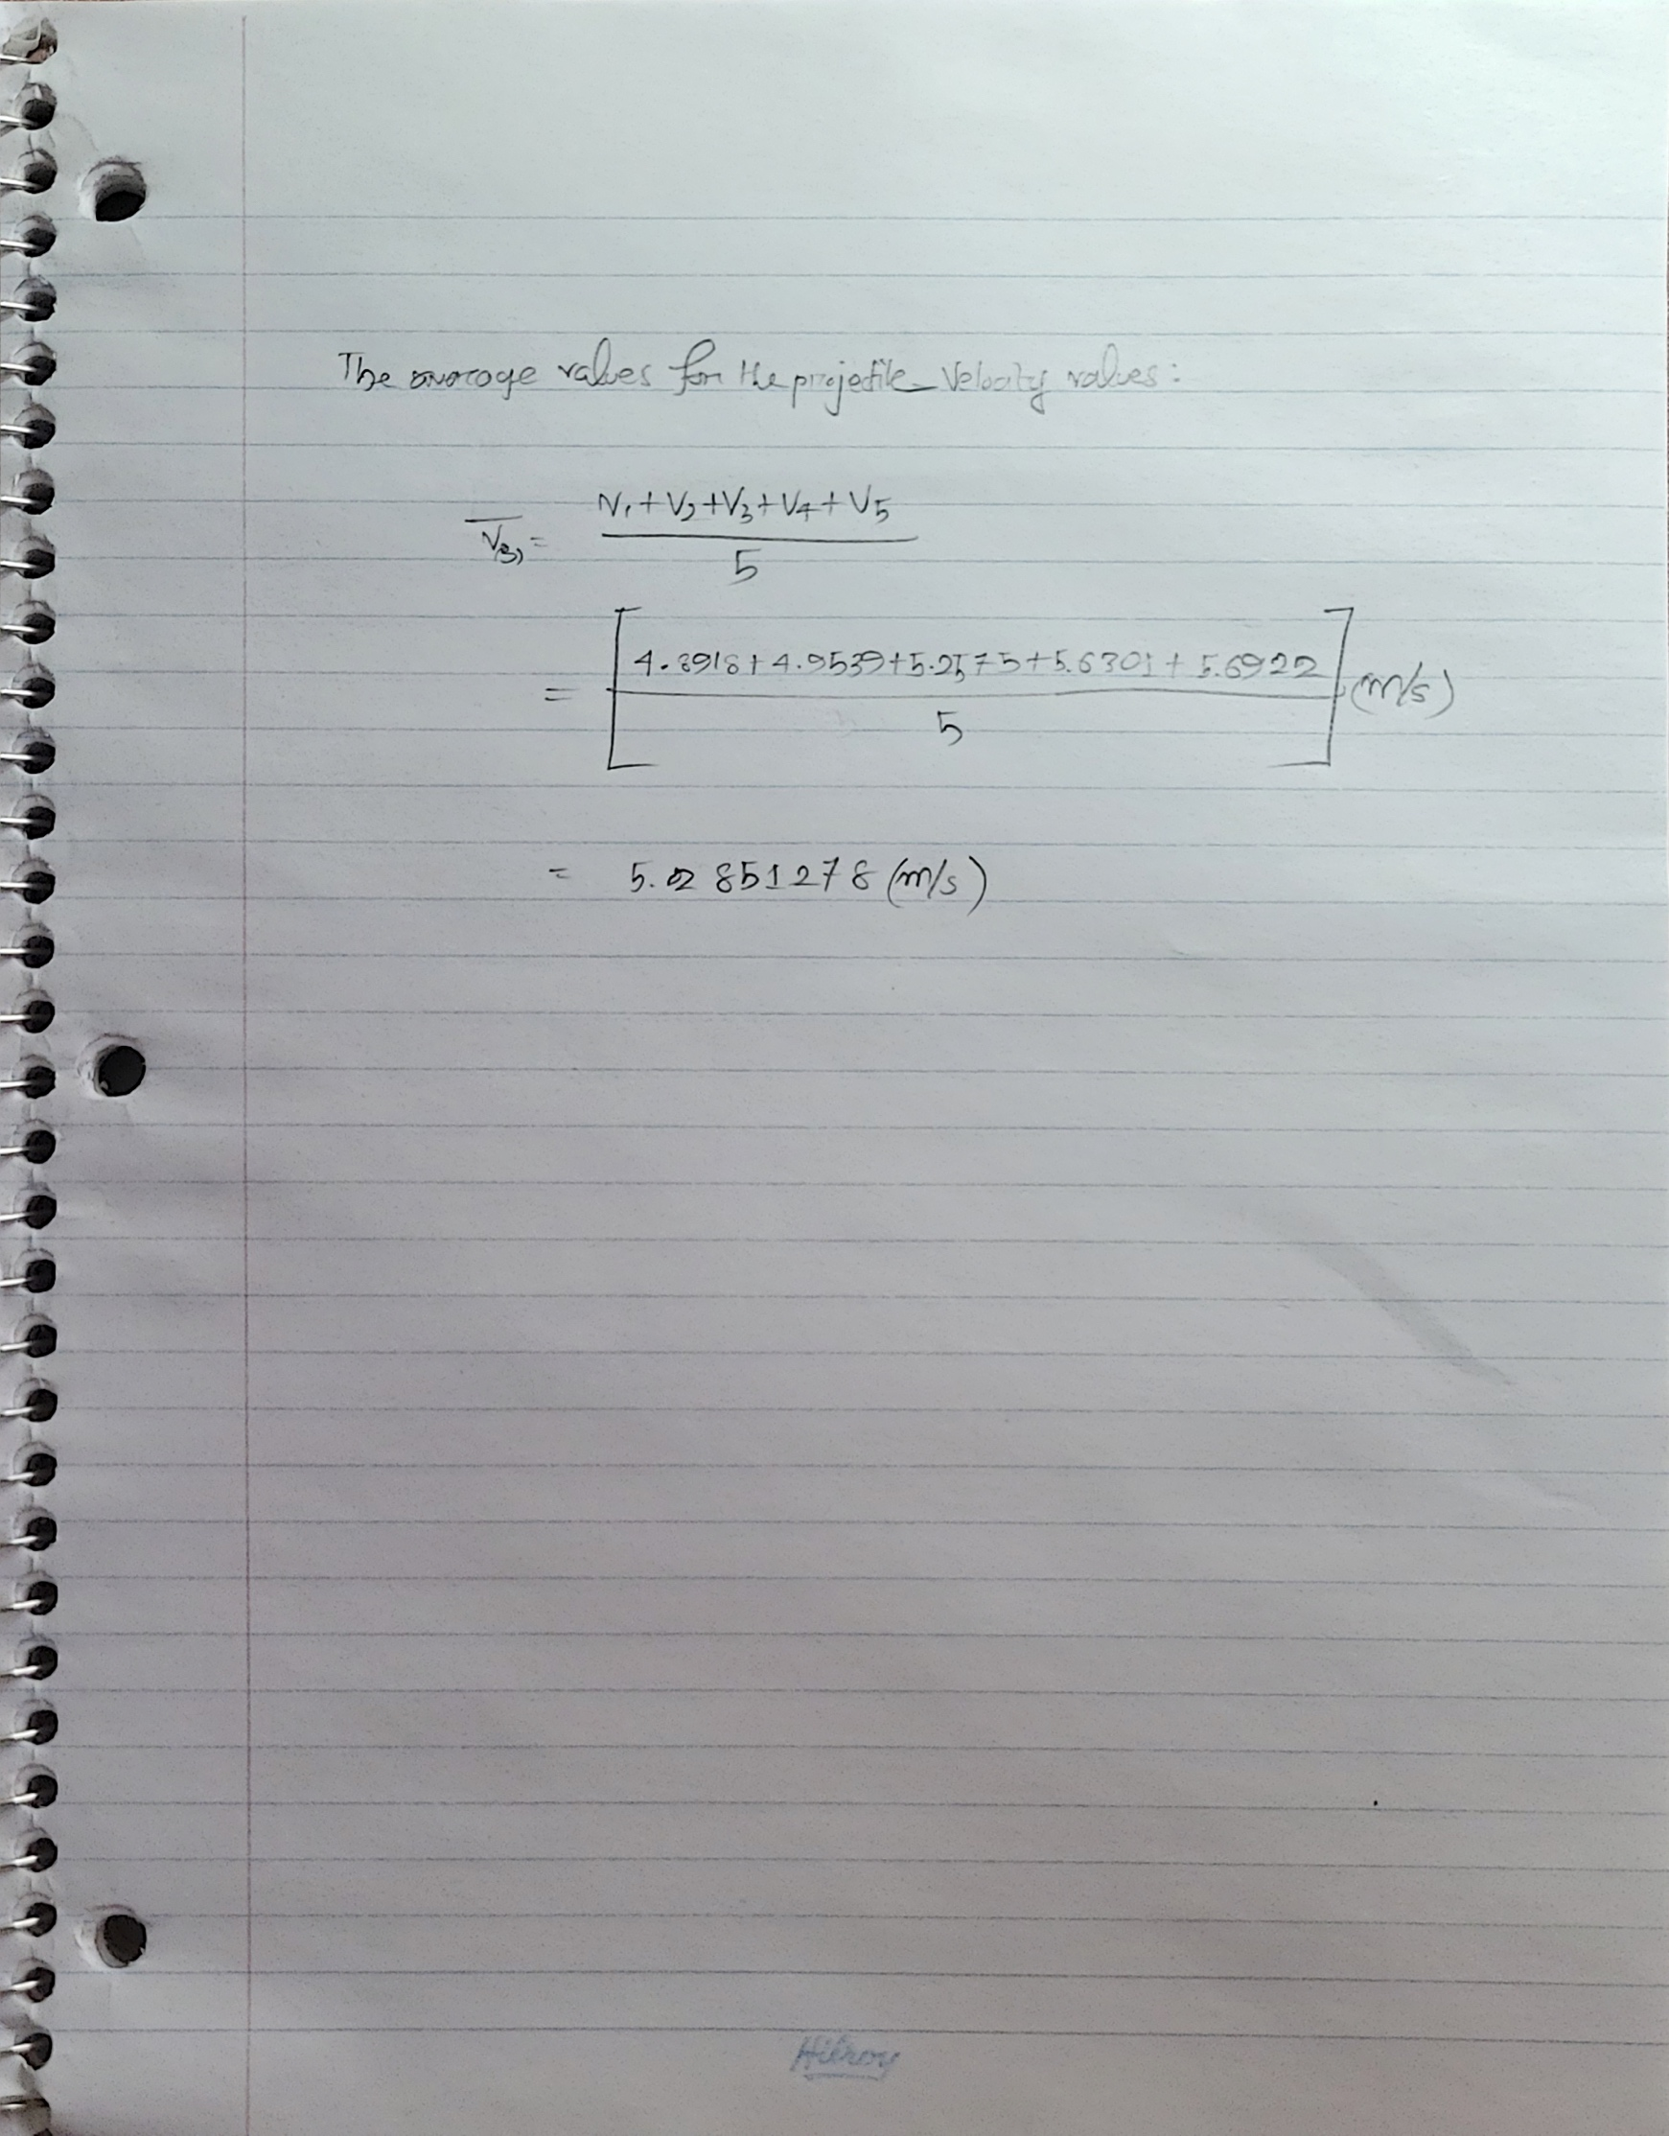

***Figure: The average value of the velocities.***

1. **Calculate your predicted height of the pendulum based on your measurements and the determined speed of the projectile.**

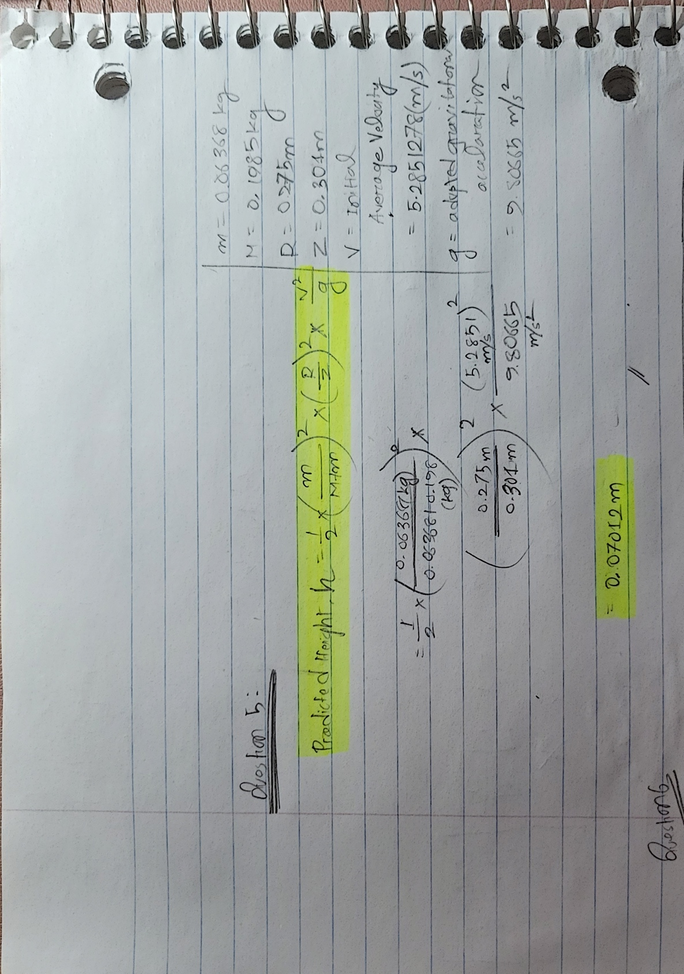

***Figure: Predicted Height from given values.***

1. **Use uncertainty propagation to determine the uncertainty in the predicted max height value, as it depends on the uncertainty of your measurements.**

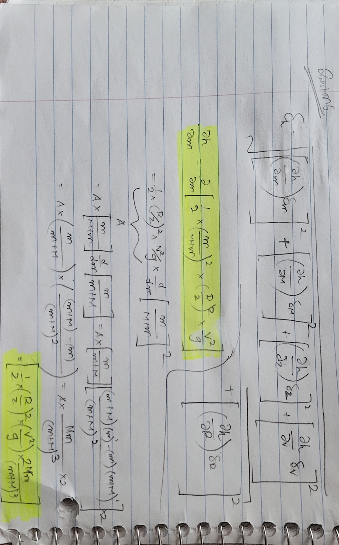

*please turn to next page*

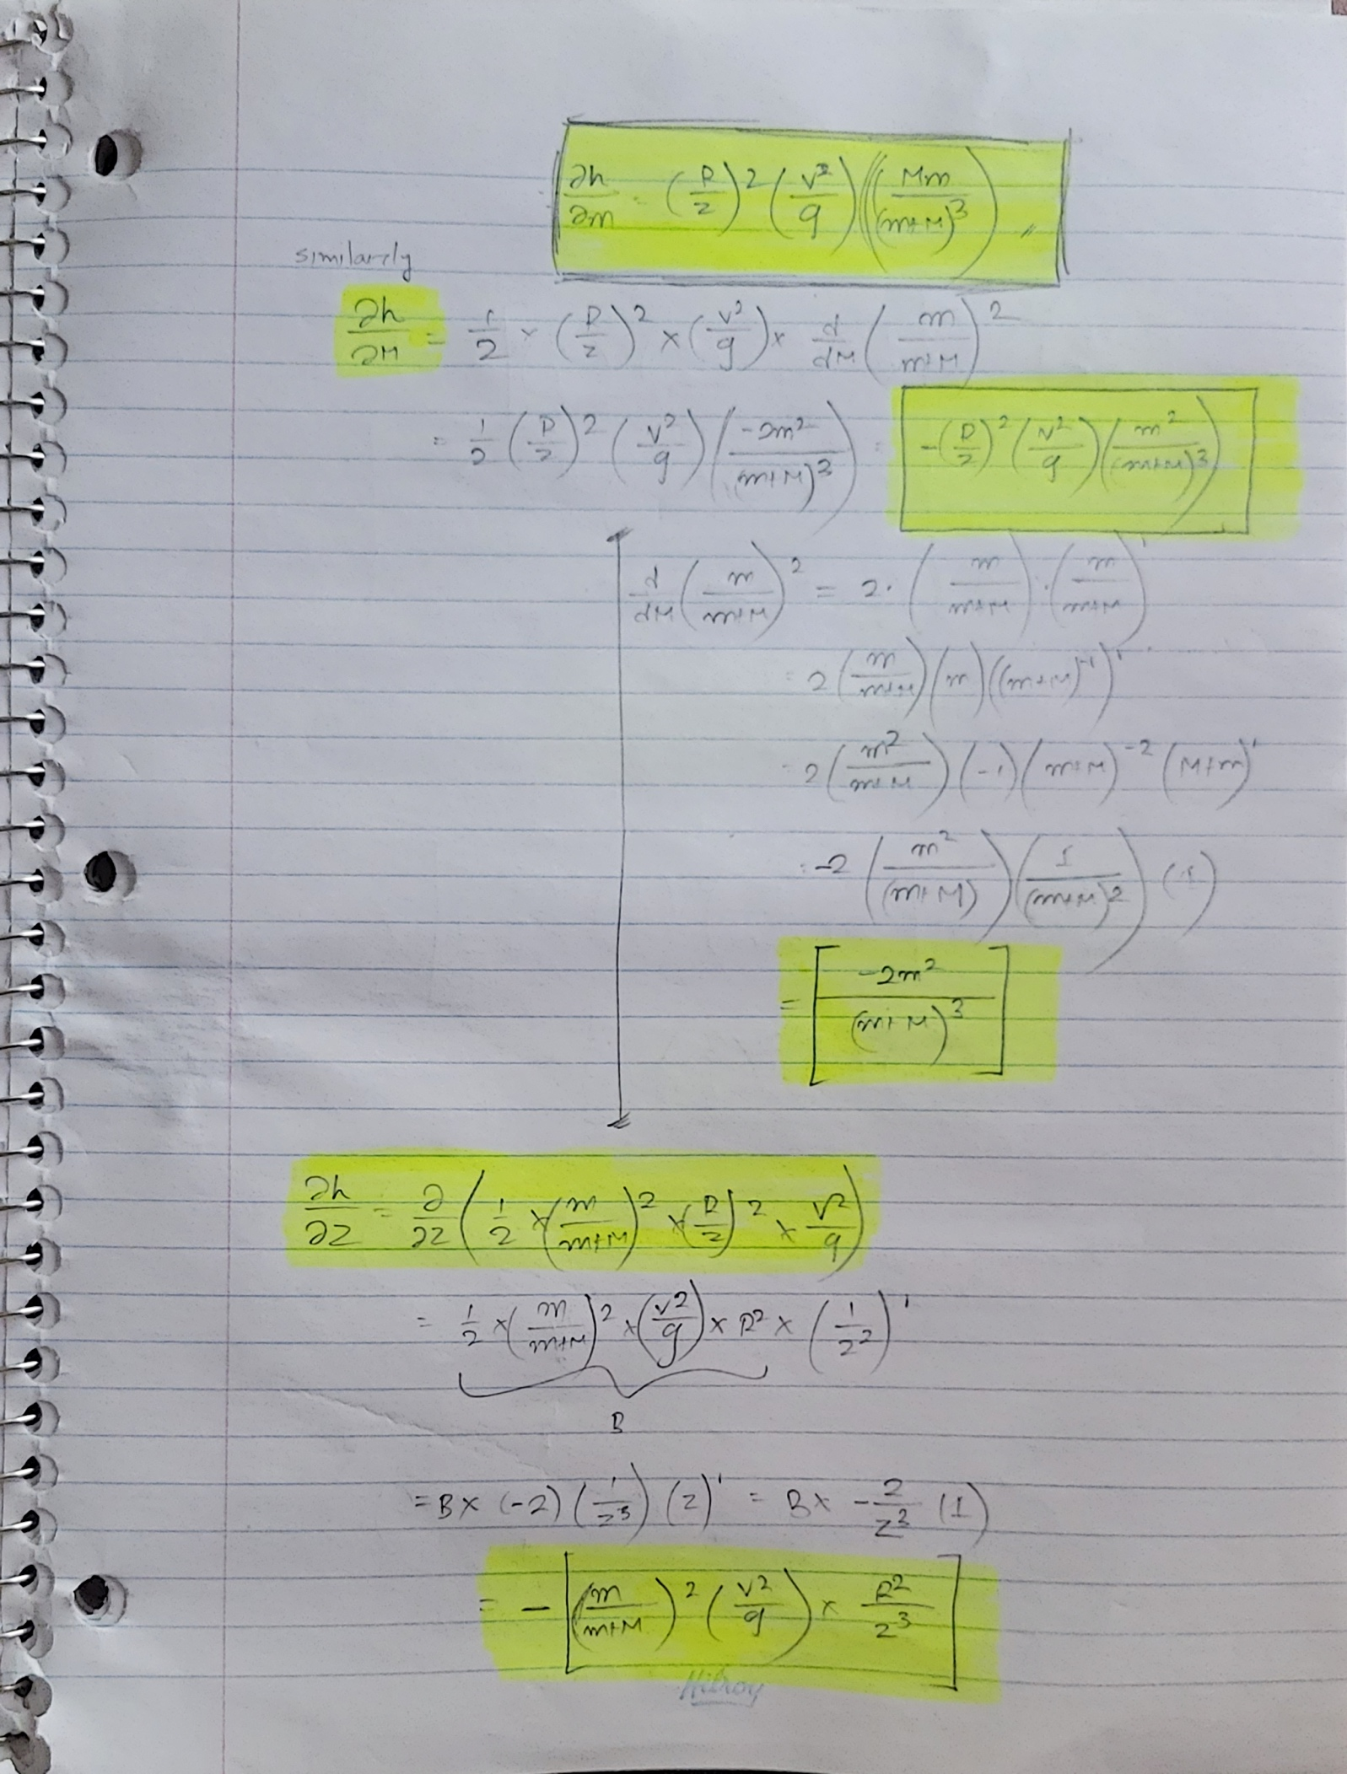

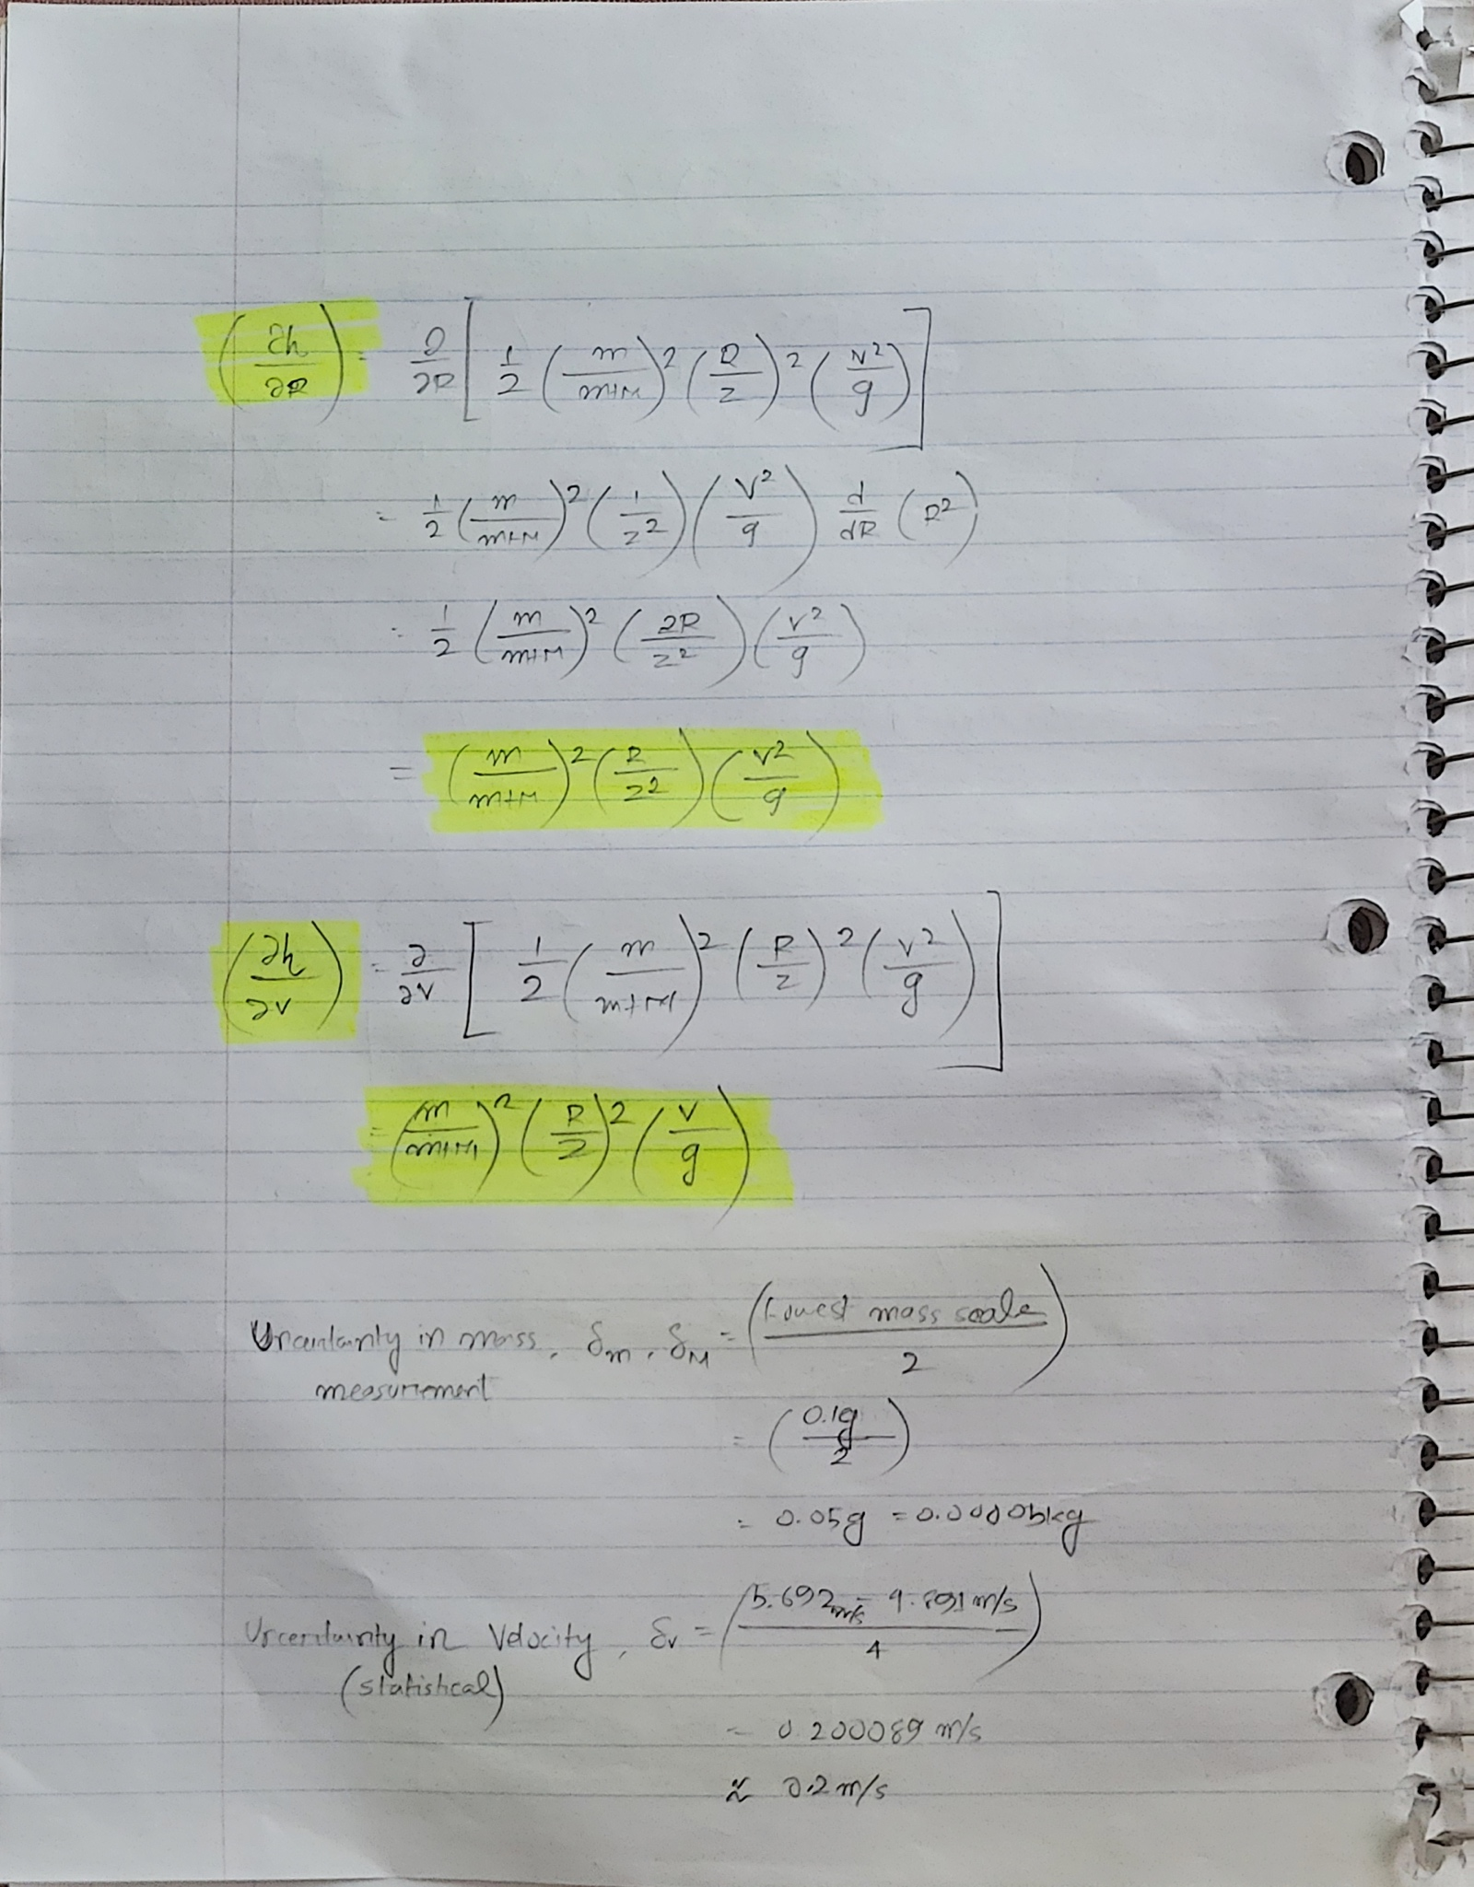

*please turn to next page*

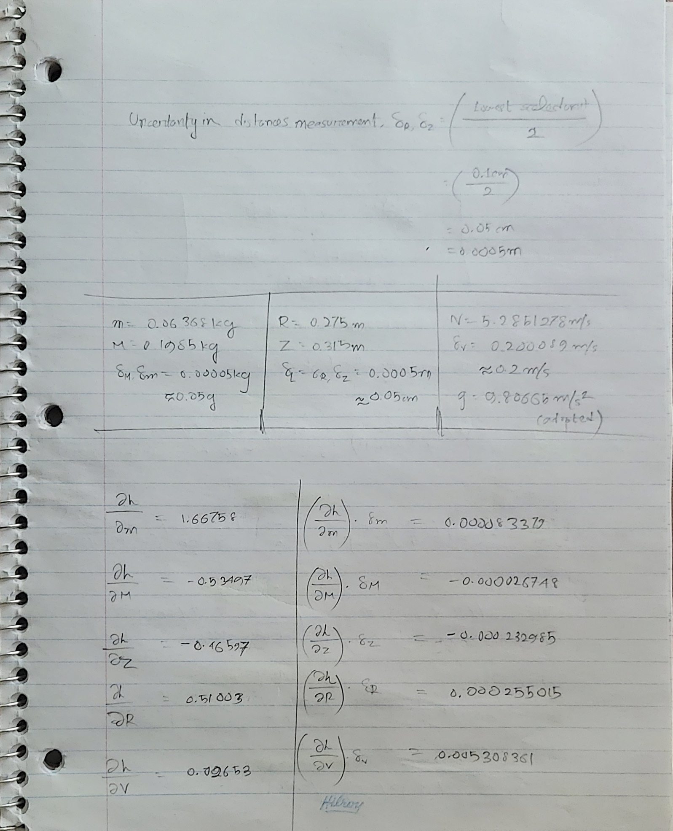

*please turn to next page*

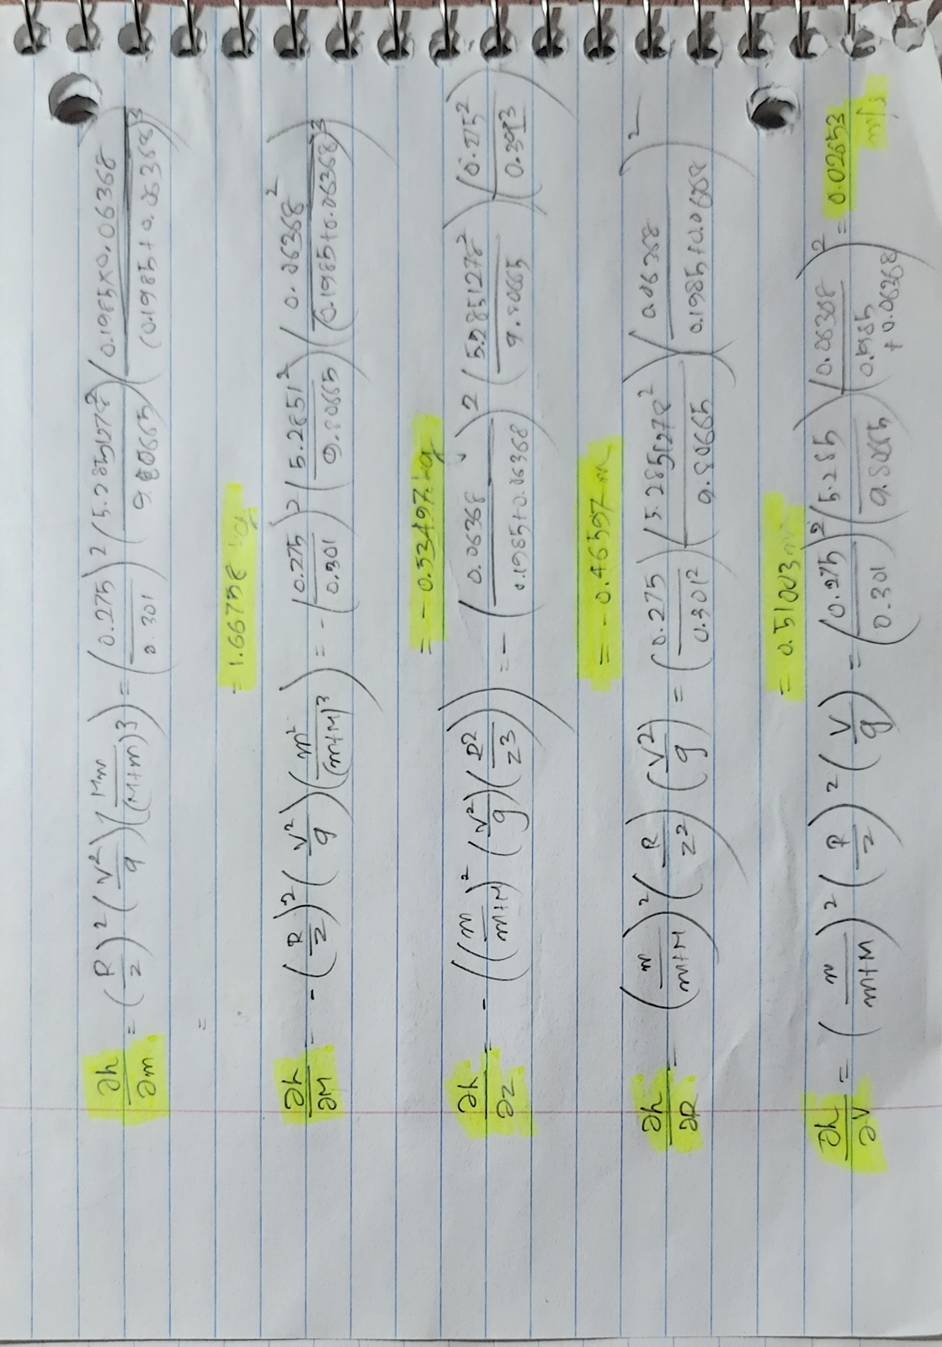

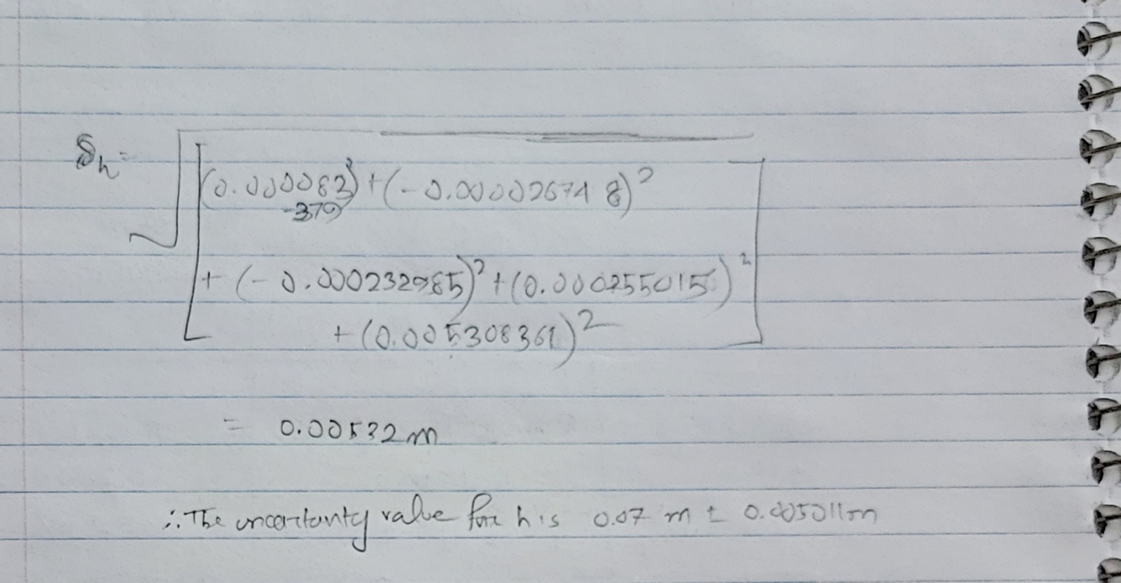

*please turn to next page*

1. Create a table of your max height information, as described in the Activity & Analysis section of the lab manual.



1. Calculate the average and uncertainty in the max height of the pendulum. It is sufficient to show the formulas you use without showing intermediate steps of plugging in numbers. You do not need to perform uncertainty propagation, as the uncertainty in height is statistical in nature.

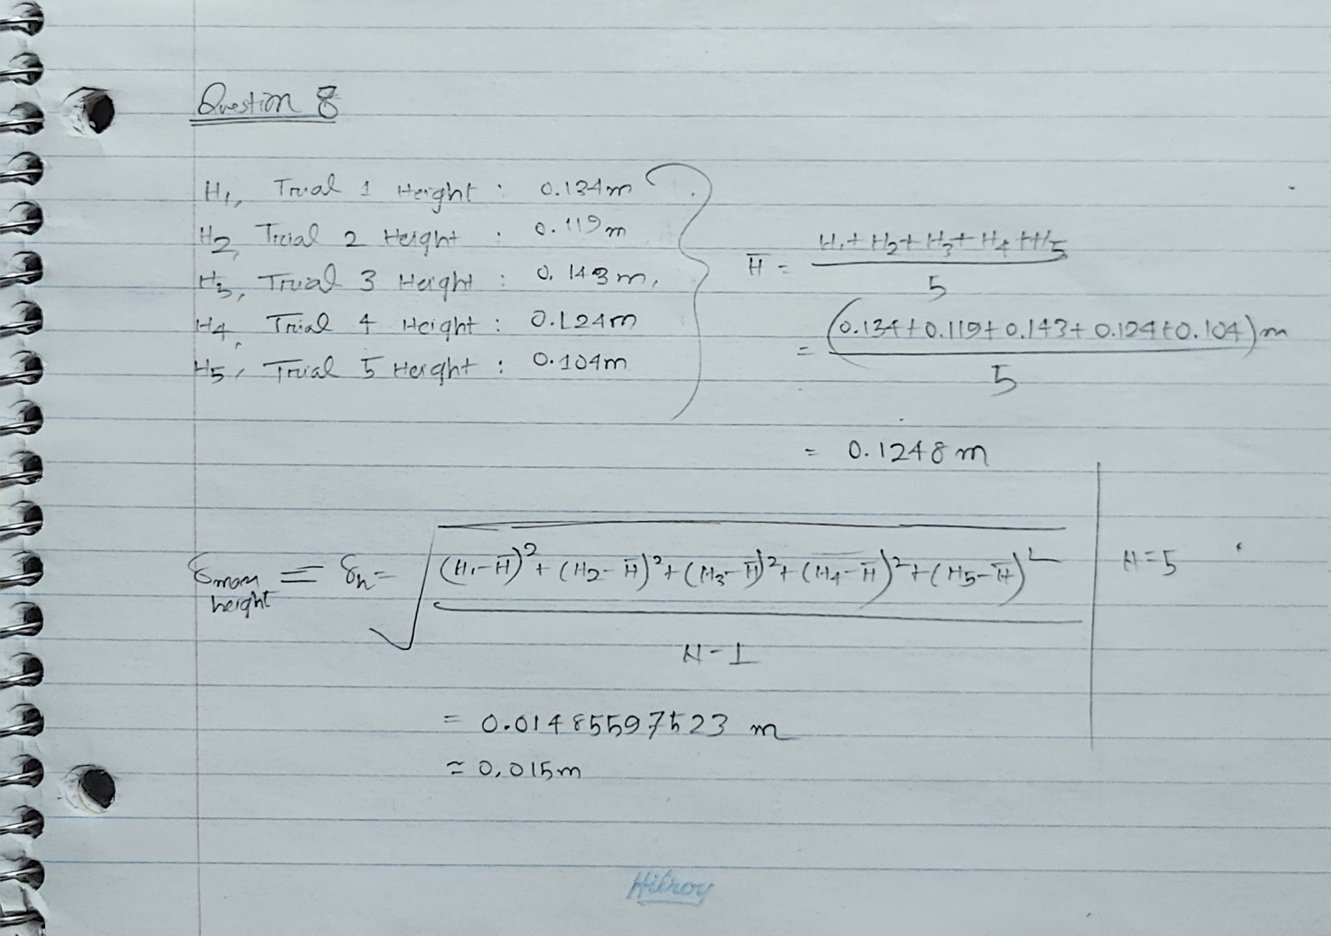

1. Compare your two answers to determine if they are statistically compatible measurements.

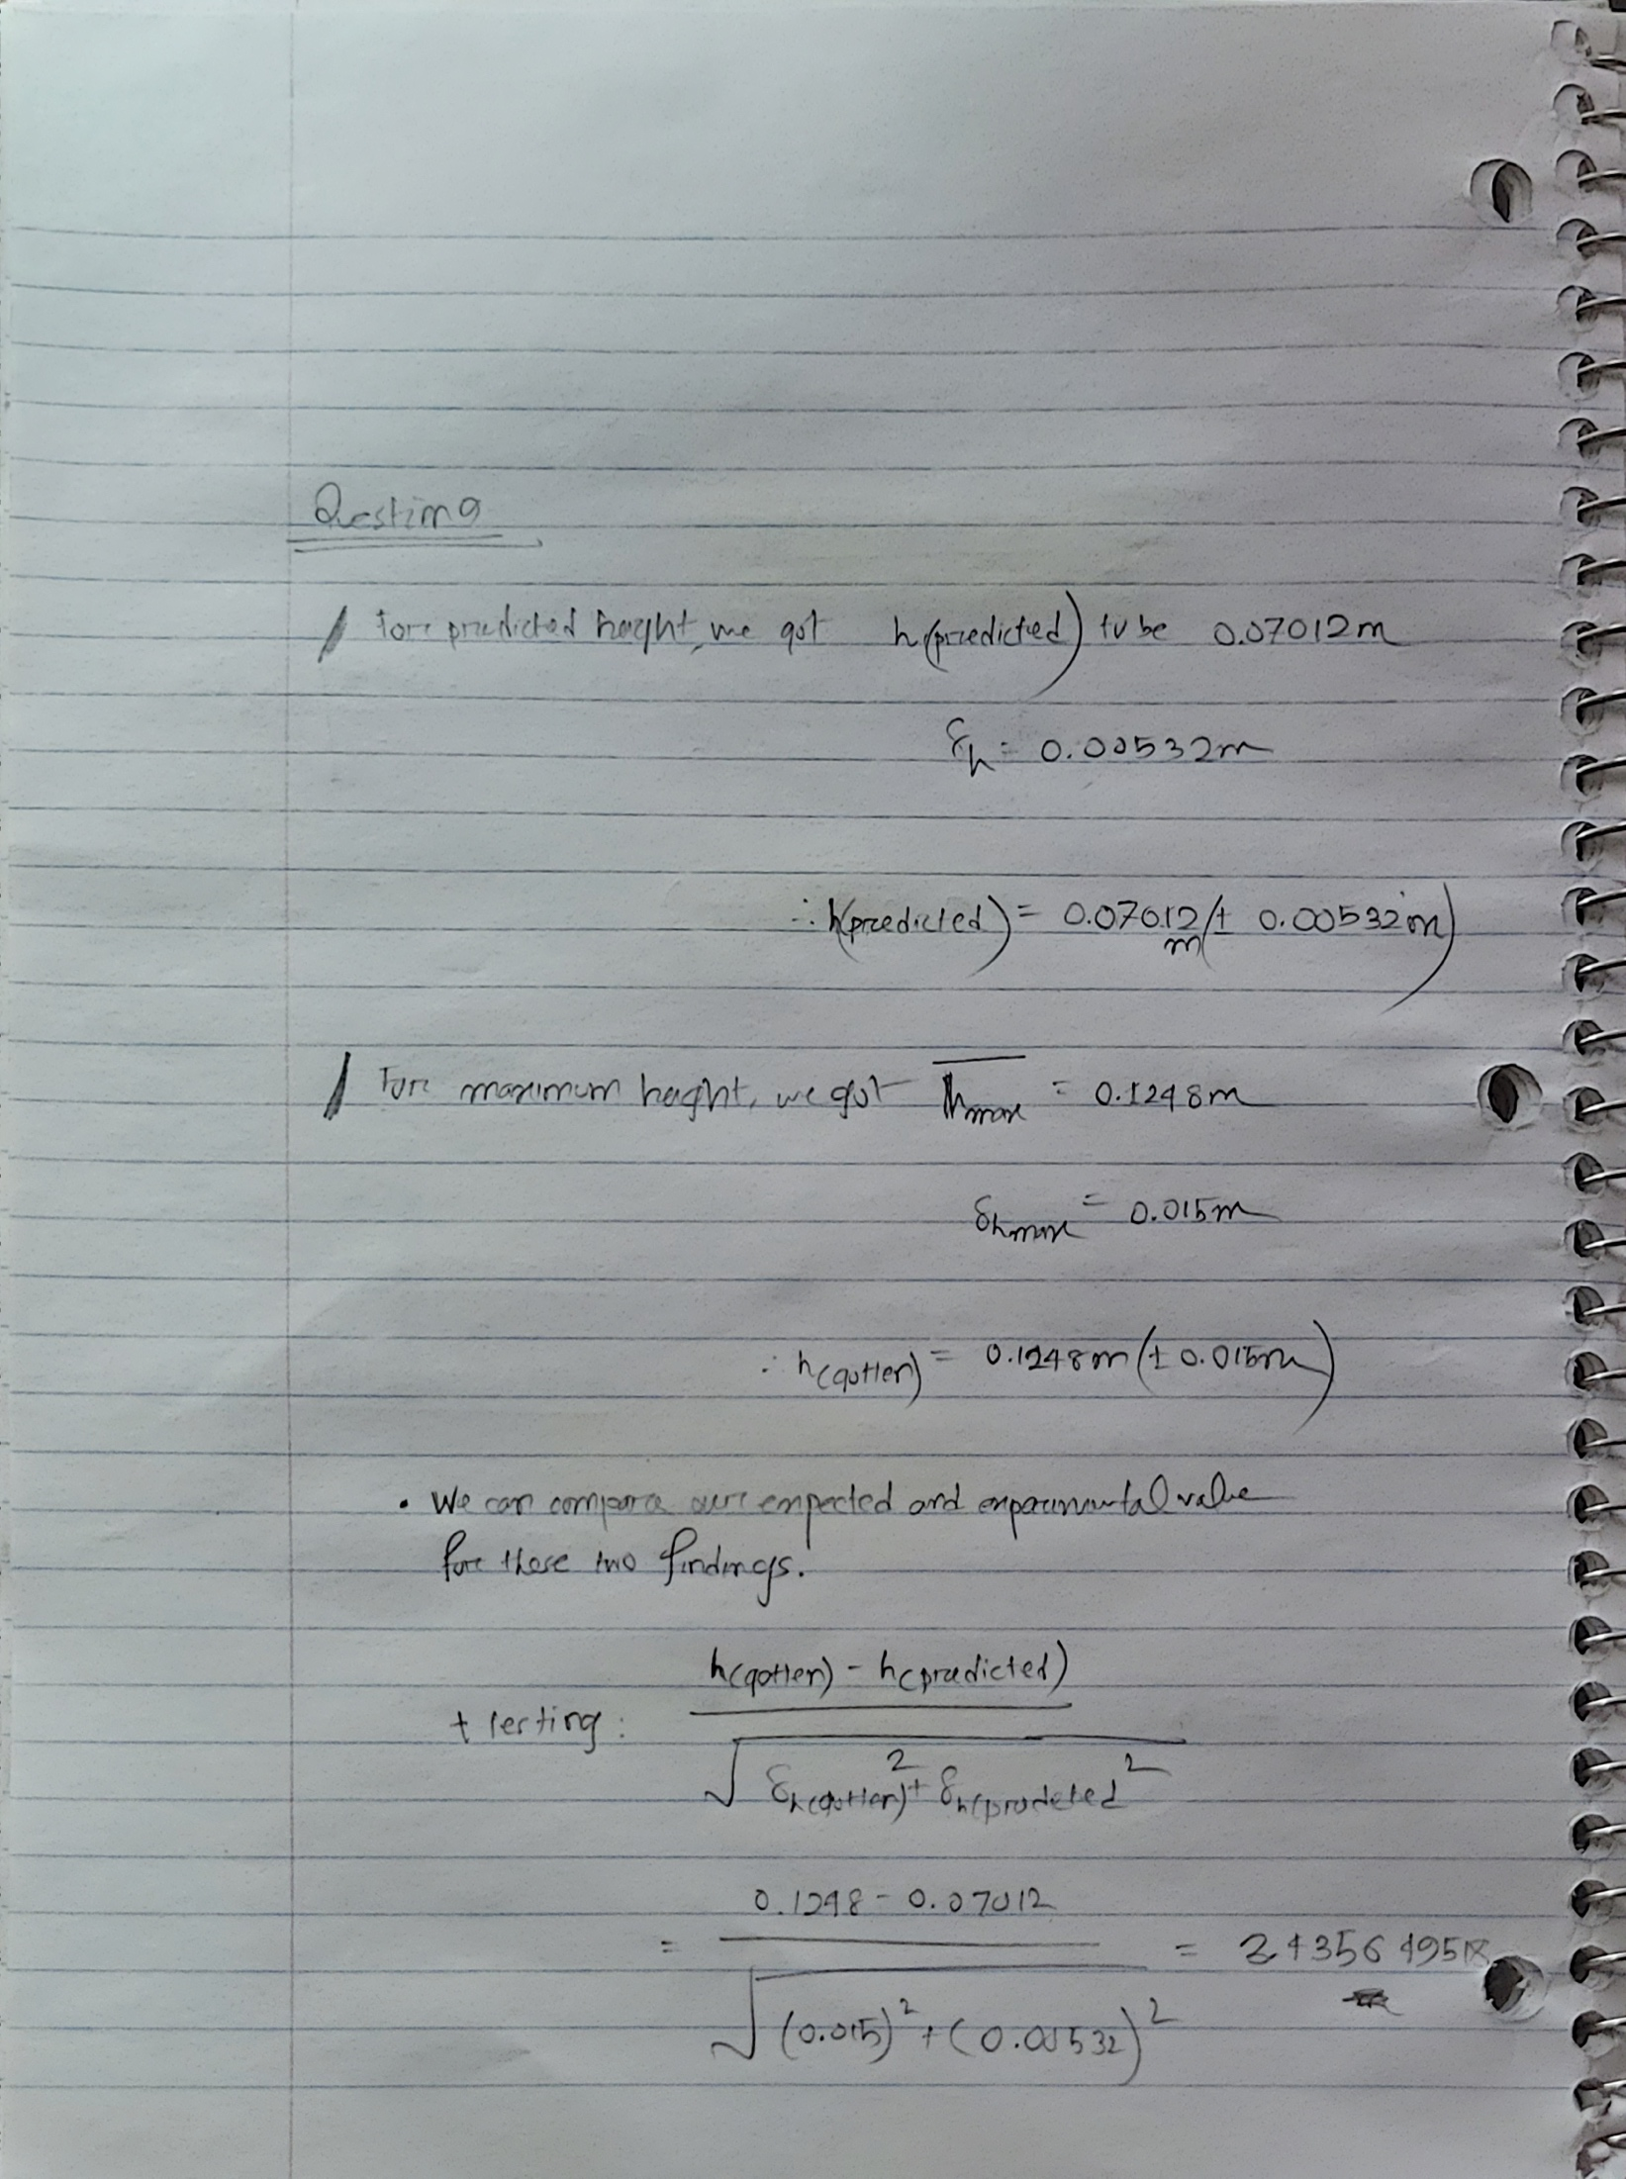

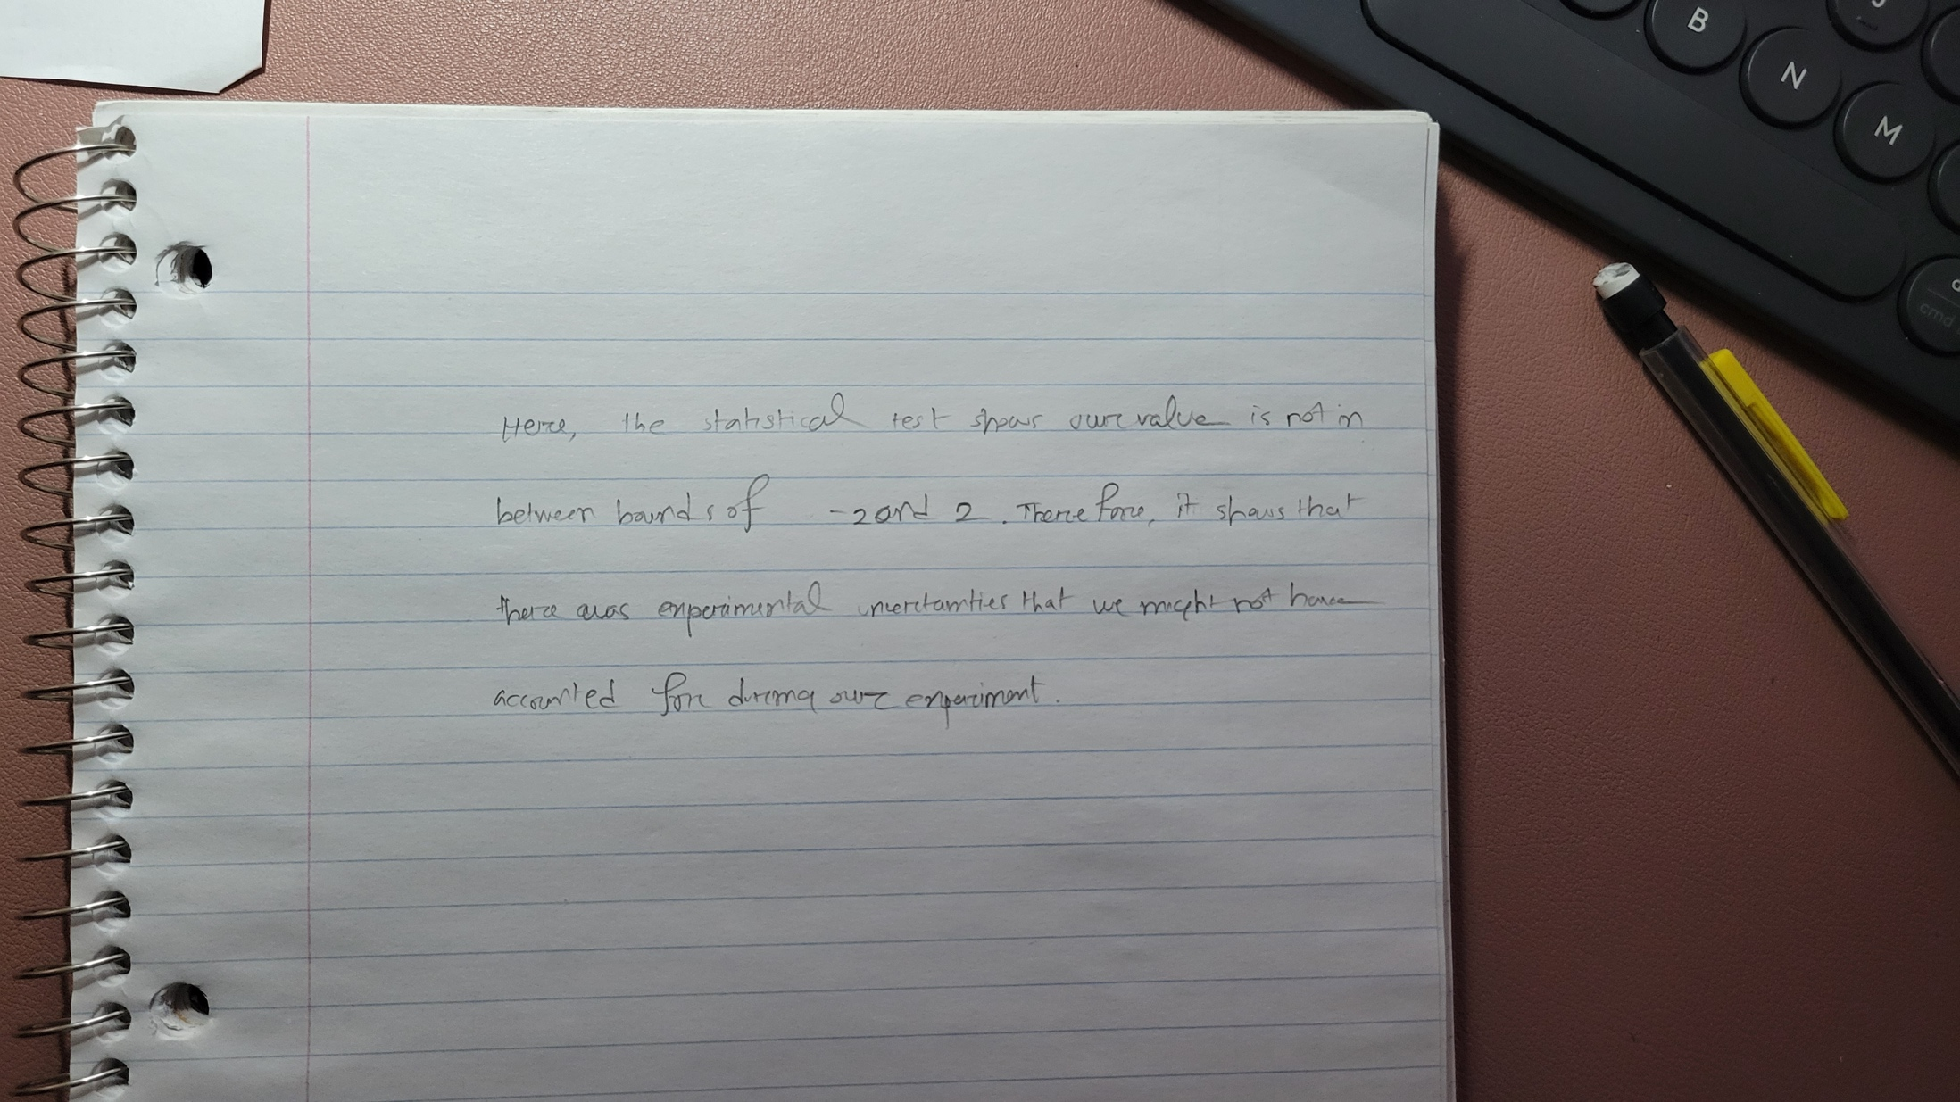

1. Respond to the following questions/instructions:
   1. What is the largest source of uncertainty in your prediction value?

The largest source of uncertainty in my finding has been the statistical uncertainty in finding the speed in each trial (Highest uncertainty among all).

* 1. This experiment neglects many possible influences. List as many as you can and discuss how they might affect the results. Use equations to justify your answers.

There are factors like air resistance (major influence in this experiment that has been neglected), experimental error in the objects, errors in finding the exact locations of the landings in each trial (like the position of the carbon papers during each trial), uncertainty in the measurements of max-height (carbon paper marking inconsistency).

* 1. Assuming your results are not statistically compatible (whether they are or aren’t), what is one aspect of the experiment/modelling would be good to verify/validate before claiming that the theory is incorrect? Explain how this could affect the results.

My results / findings from the experiment have not been statistically compatible. I think finding, reweighting, re-measuring each of the trials – and repeating the experiment for a couple more times could have given a more compatible aspect of the findings in this experiment.

* 1. What is another aspect of the experiment/modelling that would be good to verify/validate? Explain how this could affect the results.